BUSINESS PARNERSHIP LETTER

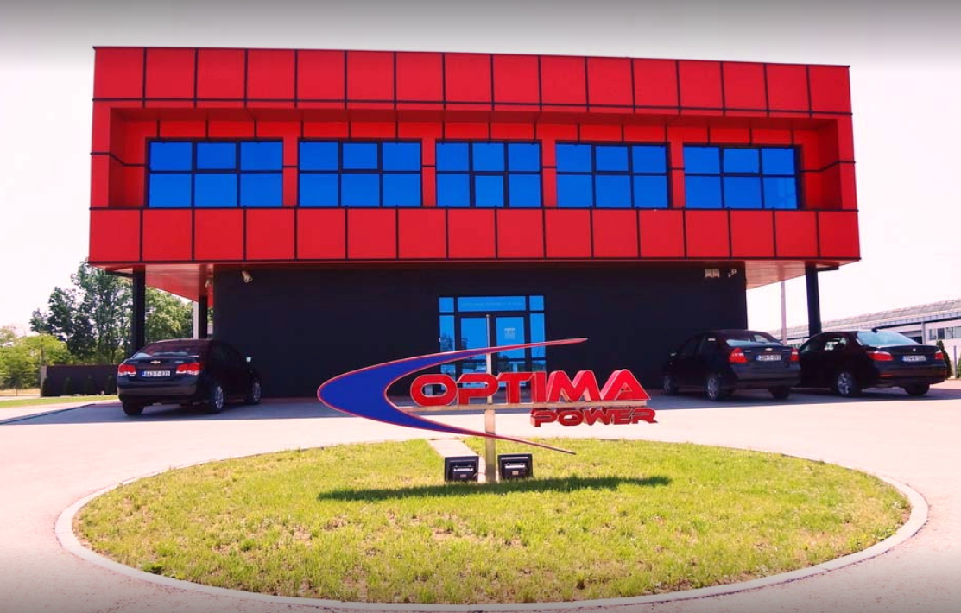

Dear Madams and Sirs,

We OPTIMA Power d.o.o. (Limited – LTD) would like to present shortly in this letter our Company and to offer a partnership for the scope of our company.

OPTIMA Power LTD. is a service provider in the power generation and industrial rotating equipment which are located on Balkans. Our tension is to extend our business to manufacturing of all mechanical parts for several industries.

OPTIMA Power LTD. is located in Modriča, Republika Srpska, Northern part of Bosnia and Herzegovina close to European Union border which is distanced approximately 16km.

Our location and contact information will be find:

https://www.optima-power.ba/en/contacts

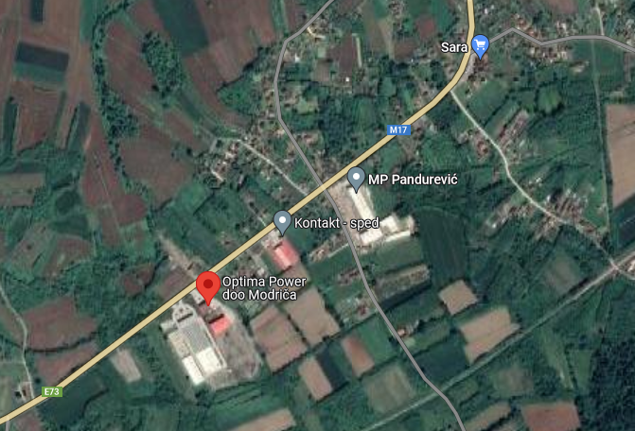

Scope of work which OPTIMA Power LTD. provide incudes supervision, overhaul and delivery of spare parts for steam turbines, generators, auxiliaries and other rotating equipment in power generation and industry. With our experienced personnel we are consistently able to meet the requirements of our clients in power industry. More than 12 years we are service solution partner GE Power (ex-Alstom/ABB/BBC) for Balkan market.

Our offering services:
- Consulting
- Supervising
- Technical advice (TFA)
- EHS services
- Preparation and execution of projects
- Professional fitters for turbines, generators, compressor, pumps, valves
- Engineering services of re-engineering and design
- Rental of fully equipped tools, office and workshop containers
- Engineering and manufacturing of transport frames for rotating equipment

Sales portfolio:
- Screws (including expansion)
- Nuts
- Expansion sleeves
- Turbine sealing segments
- Clamping rings VP turbine (high pressure)
- Generating sealing rings
- Generator coolers
- Shafts, spindles
- Sliding / Journal Bearings
- Shrink rings
- Electrical bolt Heaters
- Blades for Gas and Steam turbine
- Pumps and parts

Optima Power LTD have permanent cooperation with the following companies:

- GE Power GmbH – Germany (former ALSTOM, ABB, BBC)
- Elektroprivreda Srbije EPS – Serbia
- Alumina LTD Zvornik – BiH
- GE Energy Israel – Israel
- FEROMONT AD Beograd - Serbia
- Optima Grupa Banja Luka – BiH
- ITH GmbH - Germany

Our references:
- ALSTOM Power GmbH Mannheim - Germany
- General Electric GmbH Mannheim - Germany
- Thermal Power Plant Nikola Tesla A Obrenovac - Serbia
- Thermal power plant Nikola Tesla B Obrenovac - Serbia
- Joule Enerji Bursa - Turkey
- Thermal Power ICDAS Çanakkale - Turkey
- Thermal Power Plant - Termica de Meriama – Spain
- Thermal Power Plant Sines - district Setubal - Portugal
- Thermal Power Plant - Pego Santarem – Portugal
- GE Power Israel - PP DSW SDOM – Israel
- GE Power Israel - PP Rutenberg - Israel
- Alumina Ltd Zvornik - alumina, hydrates, zeolites and water glass – BiH
- Oil refinery Modrica - Optima Grupa – BiH

OPTIMA Power LTD. is a rarely which is specialized for the power generation business on the Balkan market. We are offer partnership and search potential partners for investments in our company to increase our potential on our market, European community and worldwide.

ATTACHMENT:
Presentation of the OPTIMA Power LTD.

CONTACT FOR FUTURE REQUESTS:

Managing Director: Mr. Davor Karalić
E-mail: davor.karalic@power-optima.com
Phone: +387 53 490 240
GSM: +387 65 162 453
WEB: www.optima-power.ba

Technical director: Mr. Milan Stanković
E-mail: milan.stankovic@power-optima.com
Phone: +387 53 490 240
GSM: +387 65 851 468
WEB: www.optima-power.ba

In anticipation of your contact with kind regards,
Davor Karalić and the team of OPTIMA Power LTD.

